Deploying SSIS package:

Two options to deployment:

To the instance of SQL server.

To the File system.

It creates manifest file.

Debugging and Error Handling with SSIS Packages

SQL Server 2005 Integration Services (SSIS) provides several ways to handle errors at different levels of the SSIS architecture.

For example, at the control-flow level, you can add a failure constraint that, if an error occurs, redirects the workflow to a specified alternate task.

Similarly, in the data flow, if a row causes an error in a transformation, you can send the row out an error path. SSIS even includes event-handling capabilities that let you trap OnWarning and OnError events.

Short answer:

(1) At the control-flow we can add failure constraint

(2) At the data flow, we can use “Error Path” to send the output.

(3) Also, we can use event-handler capabilities like onWarnig and OnError events.

(4) Also, we can configure two things 1) Package Transaction 2) Checkpoints

(5) Errors occur because of unexpected data values, we can use data converter.

To Learn in detail:

http://technet.microsoft.com/en-us/library/cc304419.aspx

Package Security

Package has database name, connection strings, SMTP, username, password, FTP, file system addresses. These all data moving through the pipeline so security is very important thing in packages.

In the property of package, there is Security option that we can use it. It has properties like

ProtectionLevel Property

PackagePassword Property

If the packages are stored in SQL Server, we can protect packages by database-level roles. Packages are stored in msdb database → Sysdtspackage90 table.

Db_dts_admin – full permissions.

Db_dtsltdUser – developer access to own packages.

Db_dtsoperator – execute only.

If the packages are stored in File system, we can protect them using NTFS permission.

We can use schema and role members property for user’s permission.

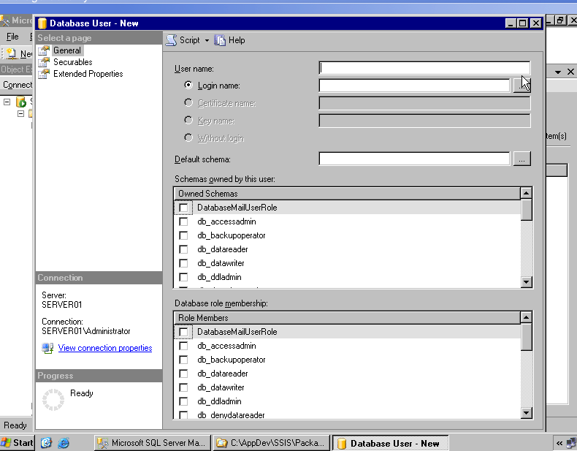

Using Digital certificates

What is BI?

BI is tool for anlysis monitor and forcasting the business process. it helps to make decisions and better performance.

What is Universe?

It’s Interface between Users and data warehouse.

BI tool in market?

1)MICROSTRATEGY
2)BUSINESS OBJECTS CRYSTAL REPORTS
3)COGNOS REPORT NET
4)MS-OLAP SERVICES
I have got these queries from someone and I would like to share my views. I dont claim my answers to be correct and hence wherever you dont agree, please let me know and share your views.
If you have any questions or comments, please post them.
Question:How you generally Approach to ur Analytics Project?
Answer: Any project should start from defining the scope of the project and the approach
should not be to deviate from the scope.
Then the project should be functionally divided into smaller modules generally done by
project managers alongwith technical and functional leads.
The functional leads then decide on majorly three things:
1. According to the defined scope of the project they start gathering requirements while
interacting with the clients.
2. They had a discussion with the technical leads and try to reach a solution.
3. Technical leads decides what schemas to create and what requirements are going to
fulfill by that schema.
Technical leads discuss all this with the developers and try to close requirements.
Simultaneously testing and deployment is planned in a phased manner.
Question: How we are going to decide which schema we are going to implement in the data warehouse?
Answer: One way is what is mentioned in Question above.
If you ask me to blindly create schemas for the warehouse without knowing any requirements,
I will simply first divide the schemas on the basis of functional areas of an Organisation
which are similar to the modules in an ERP like sales, finance, purchase, inventory,
production, HR etc.
I will broadly describe the expected analysis an organisation would like to do in every
module. I think this way you would be able to complete at least 40-50 % of the
requirements. To move ahead, study the data and business and you can create few more
schemas.
Question: What are the Challenges You Faced while making of Reports?
Answer: Making of report has never been a difficult task. But problem comes when users
are reluctant to adopt a new system. I have experienced that if you are not able to create
the report in exactly the way they used to see, they will keep asking for the changes. Your
approach should be to first show them what they want to see and then add more information
in the report.
Question: What you will do when your Report is not Fetching Right Data?
Answer: this is the biggest problem in report creation and verification. There could be two
reasons for report not fetching the right data.
1. Mostly clients do not have correct data in their database and on top of that to correct
the results they make some changes at the report level to bring the desired result which
you may not e aware of while creating the reports. Clients try to match the data with their
existing reports and you never get the correct results. you try to discover the things and
at later stage come to know of all these problems and you are held responsible for this
delay. Hence always consult the SPOC(Single Point of Contact) and try to understand the
logic they have used to generate their reports.
2. If the database values are correct, there there could be a problem with the joins and
relations in the schema. You need to discover that analysing and digging deep into the
matter.
There are more questions which I will try to answer later.
The questions are very specific to OBIEE and I dont have much experience in that. Hence you may not agree to my answers, but wherever please post a comment and let me know too.
Question: How analytics Process Your Request When you Create your Requests.
Answer: If the Question means how does Oracle BI Analytics Server processes the user requests, the answer is- Oracle BI server converts the logical SQL submitted by the client into optimised physical SQL which is then sent to the backend database. Also in between it performs various tasks like converting the user operations like user selections to form a logical SQL, checking and verifying credentials, breaking the request into threads(as Oracle BI is a multi threaded server), processes the requests, manages the cached results, again converting the results received from the database into user presentable form etc.
Question: From where u Get the Logical Query of your Request?
Answer: The logical SQL generated by the server can be viewed in BI Answers. If I have not understood the question, Please raise your voice.
Question: Major Challenges You Faced While Creating the RPD??????
Answer: Every now and then there are problems with the database connections but the problem while creating the repository RPD files comes with complex schemas made on OLTP systems consisting of lot of joins and checking the results. Th type of join made need to be checked. By default it is inner join but sometimes the requirement demands other types of joins. There are lot of problems with the date formats also.
Question: What are Global Filter and how thery differ From Column Filter?
Answer: Column filter- simply a filter applied on a column which we can use to restrict our column values while pulling the data or in charts to see the related content.
Global filter- Not sure. I understand this filter will have impact on across the application but I really dont understand where and how it can be user. I heard of global variables but not global filters.
How to make the Delivery Profilers Work?
When we are Use SA System how Does SA Server understand that It needs to use it For Getting
the User Profile information?
Where to Configure the Scheduler?
Answer: I am not sure if Iam correct but we configure the OBIEE schedular in database.
Question: How to hide Certain Columns From a User?
Answer: Application access level security- Do not add the column in the report, Do not add the column in the presentation layer.
Question:How can we Enable Drills in a Given Column Data?
Answer: To enable Drill down for a column, it should be included in the hirarchy in OBIEE. Hyperion IR has a drill anywhere feature where dont have to define and can drill to any available column.
Question: Is Drill Down Possible without the attribute being a Part of a Hierarchical Dimension?
Answer: No
Question: How do u Conditional Format.?
Answer: while creating a chat in BI Answers, you can define the conditions and can apply colour formatting.
Question: What is Guided Navigation?
Answer: I think it is just the arrangement of hyperlinks to guide the user to navigate between the reports to do the analysis.
How is Webcat File Deployed Across Environment?
Question: How the users Created Differs From RPD/Answers/Dashboards Level?????
Answer: RPD users can do administrator tasks like adding new data source, create hirarchies, change column names where as Answers users may create new charts, edit those charts and Dashboard users may only view and analyse the dashboard or can edit dashboard by adding/removing charts objects.
Question: Online/Offline Mode how it Impact in Dev and Delpoyment????
Answer: Online Mode- You can make changes in the RPD file and push in changes which will be immediately visible to the users who are already connected. This feature we may use in production environment.
Offline mode- can be useful in test or development environment.
Questions: Explan me the Schema in Your Last Project???????

When to use clustered index:
If you are searching data in table that belongs to primary key
If you are selecting large amount of data then clustered is good.
When to use non-clustered index:
If you are searching non primary key in table then use it.
If you are selecting small amount of data then non clustered is good.

Increase Query/stored procedure performance.
(1)Using SET NOCOUNT ON when you really don’t need to count the number of rows increase the performance.
(2)Access table with NOLOCK: most databases don’t required to transaction safety at that time we can use NOLOCK to gain performance.
(3) Creating indexing: Clustered index is more useful for the data that is more often searched, because the data is sorted. Non-Clustered index find the location of data value in the table and then retrieves the data directly from that location.
(4) Statistics

Question 1 - True or False - Using a checkpoint file in SSIS is just like issuing the CHECKPOINT command against the relational engine. It commits all of the data to the database.
False. SSIS provides a Checkpoint capability which allows a package to restart at the point of failure.
Question 2 - Can you explain the what the Import\Export tool does and the basic steps in the wizard?
The Import\Export tool is accessible via BIDS or executing the dtswizard command.
The tool identifies a data source and a destination to move data either within 1 database, between instances or even from a database to a file (or vice versa).
Question 3 - What are the command line tools to execute SQL Server Integration Services packages?
DTSEXECUI - When this command line tool is run a user interface is loaded in order to configure each of the applicable parameters to execute an SSIS package.
DTEXEC - This is a pure command line tool where all of the needed switches must be passed into the command for successful execution of the SSIS package.
Question 4 - Can you explain the SQL Server Integration Services functionality in Management Studio?
You have the ability to do the following:
Login to the SQL Server Integration Services instance
View the SSIS log
View the packages that are currently running on that instance
Browse the packages stored in MSDB or the file system
Import or export packages
Delete packages
Run packages
Question 5 - Can you name some of the core SSIS components in the Business Intelligence Development Studio you work with on a regular basis when building an SSIS package?
Connection Managers
Control Flow
Data Flow
Event Handlers
Variables window
Toolbox window
Output window
Logging
Package Configurations
Question Difficulty = Moderate
True or False: SSIS has a default means to log all records updated, deleted or inserted on a per table basis.
False, but a custom solution can be built to meet these needs.
What is a breakpoint in SSIS? How is it setup? How do you disable it?
A breakpoint is a stopping point in the code. The breakpoint can give the Developer\DBA an opportunity to review the status of the data, variables and the overall status of the SSIS package.
10 unique conditions exist for each breakpoint.
Breakpoints are setup in BIDS. In BIDS, navigate to the control flow interface. Right click on the object where you want to set the breakpoint and select the 'Edit Breakpoints...' option.
Can you name 5 or more of the native SSIS connection managers?
OLEDB connection - Used to connect to any data source requiring an OLEDB connection (i.e., SQL Server 2000)
Flat file connection - Used to make a connection to a single file in the File System. Required for reading information from a File System flat file
ADO.Net connection - Uses the .Net Provider to make a connection to SQL Server 2005 or other connection exposed through managed code (like C#) in a custom task
Analysis Services connection - Used to make a connection to an Analysis Services database or project. Required for the Analysis Services DDL Task and Analysis Services Processing Task
File connection - Used to reference a file or folder. The options are to either use or create a file or folder
Excel
FTP
HTTP
MSMQ
SMO
SMTP
SQLMobile
WMI
How do you eliminate quotes from being uploaded from a flat file to SQL Server?
In the SSIS package on the Flat File Connection Manager Editor, enter quotes into the Text qualifier field then preview the data to ensure the quotes are not included.
Additional information: How to strip out double quotes from an import file in SQL Server Integration Services
Question 5 - Can you name 5 or more of the main SSIS tool box widgets and their functionality?
For Loop Container
Foreach Loop Container
Sequence Container
ActiveX Script Task
Analysis Services Execute DDL Task
Analysis Services Processing Task
Bulk Insert Task
Data Flow Task
Data Mining Query Task
Execute DTS 2000 Package Task
Execute Package Task
Execute Process Task
Execute SQL Task
etc.
Question Difficulty = Difficult
Question 1 - Can you explain one approach to deploy an SSIS package?
One option is to build a deployment manifest file in BIDS, then copy the directory to the applicable SQL Server then work through the steps of the package installation wizard
A second option is using the dtutil utility to copy, paste, rename, delete an SSIS Package
A third option is to login to SQL Server Integration Services via SQL Server Management Studio then navigate to the 'Stored Packages' folder then right click on the one of the children folders or an SSIS package to access the 'Import Packages...' or 'Export Packages...'option.
A fourth option in BIDS is to navigate to File | Save Copy of Package and complete the interface.
Question 2 - Can you explain how to setup a checkpoint file in SSIS?
The following items need to be configured on the properties tab for SSIS package:
CheckpointFileName - Specify the full path to the Checkpoint file that the package uses to save the value of package variables and log completed tasks. Rather than using a hard-coded path as shown above, it's a good idea to use an expression that concatenates a path defined in a package variable and the package name.
CheckpointUsage - Determines if/how checkpoints are used. Choose from these options: Never (default), IfExists, or Always. Never indicates that you are not using Checkpoints. IfExists is the typical setting and implements the restart at the point of failure behavior. If a Checkpoint file is found it is used to restore package variable values and restart at the point of failure. If a Checkpoint file is not found the package starts execution with the first task. The Always choice raises an error if the Checkpoint file does not exist.
SaveCheckpoints - Choose from these options: True or False (default). You must select True to implement the Checkpoint behavior.
Question 3 - Can you explain different options for dynamic configurations in SSIS?
Use an XML file, Environment Variable, SQL Server Table, Parent Package Variable, and Registry Entry.
Question 4 - How do you upgrade an SSIS Package?
Depending on the complexity of the package, one or two techniques are typically used:
Recode the package based on the functionality in SQL Server DTS
Use the Migrate DTS 2000 Package wizard in BIDS then recode any portion of the package that is not accurate
Question 5 - Can you name five of the performance counters for SSIS and the value they provide?
SQLServer:SSIS Service
SSIS Package Instances - Total number of simultaneous SSIS Packages running
SQLServer:SSIS Pipeline
BLOB bytes read - Total bytes read from binary large objects during the monitoring period.
BLOB bytes written - Total bytes written to binary large objects during the monitoring period.
BLOB files in use - Number of binary large objects files used during the data flow task during the monitoring period.
Buffer memory - The amount of physical or virtual memory used by the data flow task during the monitoring period.
Buffers in use - The number of buffers in use during the data flow task during the monitoring period.
Buffers spooled - The number of buffers written to disk during the data flow task during the monitoring period.
Flat buffer memory - The total number of blocks of memory in use by the data flow task during the monitoring period.
Flat buffers in use - The number of blocks of memory in use by the data flow task at a point in time.
Private buffer memory - The total amount of physical or virtual memory used by data transformation tasks in the data flow engine during the monitoring period.
Private buffers in use - The number of blocks of memory in use by the transformations in the data flow task at a point in time.
Rows read - Total number of input rows in use by the data flow task at a point in time.
Rows written - Total number of output rows in use by the data flow task at a point in time.
Q1 Explain architecture of SSIS?
SSIS architecture consists of four key parts:
a) Integration Services service: monitors running Integration Services packages and manages the storage of packages.
b) Integration Services object model: includes managed API for accessing Integration Services tools, command-line utilities, and custom applications.
c) Integration Services runtime and run-time executables: it saves the layout of packages, runs packages, and provides support for logging, breakpoints, configuration, connections, and transactions. The Integration Services run-time executables are the package, containers, tasks, and event handlers that Integration Services includes, and custom tasks.
d) Data flow engine: provides the in-memory buffers that move data from source to destination.
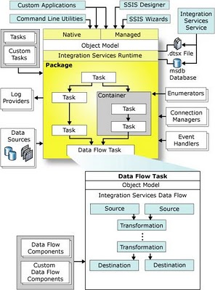
Q2 How would you do Logging in SSIS?
Logging Configuration provides an inbuilt feature which can log the detail of various events like onError, onWarning etc to the various options say a flat file, SqlServer table, XML or SQL Profiler.
Q3 How would you do Error Handling?
A SSIS package could mainly have two types of errors
a) Procedure Error: Can be handled in Control flow through the precedence control and redirecting the execution flow.
b) Data Error: is handled in DATA FLOW TASK buy redirecting the data flow using Error Output of a component.
Q4 How to pass property value at Run time? How do you implement Package Configuration?
A property value like connection string for a Connection Manager can be passed to the pkg using package configurations.Package Configuration provides different options like XML File, Environment Variables, SQL Server Table, Registry Value or Parent package variable.
Q5 How would you deploy a SSIS Package on production?
1. Create deployment utility by setting its propery as true .
2. It will be created in the bin folder of the solution as soon as package is build.
3. Copy all the files in the utility and use manifest file to deply it on the Prod.
Q6 Difference between DTS and SSIS?
Every thing except both are product of Microsoft :-).
Q7 What are new features in SSIS 2008?
explained in other post
http://sqlserversolutions.blogspot.com/2009/01/new-improvementfeatures-in-ssis-2008.html
Q8 How would you pass a variable value to Child Package?
too big to fit here so had a write other post
http://sqlserversolutions.blogspot.com/2009/02/passing-variable-to-child-package-from.html
Q9 What is Execution Tree?
Execution trees demonstrate how package uses buffers and threads. At run time, the data flow engine breaks down Data Flow task operations into execution trees. These execution trees specify how buffers and threads are allocated in the package. Each tree creates a new buffer and may execute on a different thread. When a new buffer is created such as when a partially blocking or blocking transformation is added to the pipeline, additional memory is required to handle the data transformation and each new tree may also give you an additional worker thread.
Q10 What are the points to keep in mind for performance improvement of the package?
http://technet.microsoft.com/en-us/library/cc966529.aspx
Q11 You may get a question stating a scenario and then asking you how would you create a package for that e.g. How would you configure a data flow task so that it can transfer data to different table based on the city name in a source table column?
Q13 Difference between Unionall and Merge Join?
a) Merge transformation can accept only two inputs whereas Union all can take more than two inputs
b) Data has to be sorted before Merge Transformation whereas Union all doesn't have any condition like that.
Q14 May get question regarding what X transformation do?Lookup, fuzzy lookup, fuzzy grouping transformation are my favorites.
For you.
Q15 How would you restart package from previous failure point?What are Checkpoints and how can we implement in SSIS?
When a package is configured to use checkpoints, information about package execution is written to a checkpoint file. When the failed package is rerun, the checkpoint file is used to restart the package from the point of failure. If the package runs successfully, the checkpoint file is deleted, and then re-created the next time that the package is run.
Q16 Where are SSIS package stored in the SQL Server?
MSDB.sysdtspackages90 stores the actual content and ssydtscategories, sysdtslog90, sysdtspackagefolders90, sysdtspackagelog, sysdtssteplog, and sysdtstasklog do the supporting roles.
Q17 How would you schedule a SSIS packages?
Using SQL Server Agent. Read about Scheduling a job on Sql server Agent
Q18 Difference between asynchronous and synchronous transformations?
Synchronous Transformations

A synchronous transformation processes incoming rows and passes them on in the data flow one row at a time. Output is synchronous with input, meaning that it occurs at the same time. Therefore, to process a given row, the transformation does not need information about other rows in the data set. In the actual implementation, rows are grouped into buffers as they pass from one component to the next, but these buffers are transparent to the user, and you can assume that each row is processed separately.
An example of a synchronous transformation is the Data Conversion transformation. For each incoming row, it converts the value in the specified column and sends the row on its way. Each discrete conversion operation is independent of all the other rows in the data set.
In Integration Services scripting and programming, you specify a synchronous transformation by looking up the ID of a component's input and assigning it to the SynchronousInputID property of the component's outputs. This tells the data flow engine to process each row from the input and send each row automatically to the specified outputs. If you want every row to go to every output, you do not have to write any additional code to output the data. If you use the ExclusionGroup property to specify that rows should only go to one or another of a group of outputs, as in the Conditional Split transformation, you must call the DirectRow method to select the appropriate destination for each row. When you have an error output, you must call DirectErrorRow to send rows with problems to the error output instead of the default output.
Asynchronous Transformations

You might decide that your design requires an asynchronous transformation when it is not possible to process each row independently of all other rows. In other words, you cannot pass each row along in the data flow as it is processed, but instead must output data asynchronously, or at a different time, than the input. For example, the following scenarios require an asynchronous transformation:
- The component has to acquire multiple buffers of data before it can perform its processing. An example is the Sort transformation, where the component has to process the complete set of rows in a single operation.
- The component has to combine rows from multiple inputs. An example is the Merge transformation, where the component has to examine multiple rows from each input and then merge them in sorted order.
- There is no one-to-one correspondence between input rows and output rows. An example is the Aggregate transformation, where the component has to add a row to the output to hold the computed aggregate values.
In Integration Services scripting and programming, you specify an asynchronous transformation by assigning a value of 0 to the SynchronousInputID property of the component's outputs. . This tells the data flow engine not to send each row automatically to the outputs. Then you must write code to send each row explicitly to the appropriate output by adding it to the new output buffer that is created for the output of an asynchronous transformation.
Q19 How to achieve parallelism in SSIS?
Parallelism is achieved using MaxConcurrentExecutable property of the package. Its default is -1 and is calculated as number of processors + 2.
Difference between Data flow and Control Flow
Control Flow:

- Process is the key: precedence constraints control the project flow based on task completion, success or failure
- Task 1 needs to complete before task 2 begins
- Smallest unit of the control flow is a task
- Control flow does not move data from task to task
- Tasks are run in series if connected with precedence or in parallel
- Package control flow is made up of containers and tasks connected with precedence constraints to control package flow
Data Flow:
- Streaming
- Unlink control flow, multiple components can process data at the same time
- Smallest unit of the data flow is a component
- Data flows move data, but are also tasks in the control flow, as such, their success or failure effects how your control flow operates
- Data is moved and manipulated through transformations
- Data is passed between each component in the data flow
- Data flow is made up of source(s), transformations, and destinations.
What is the Multicast Shape used for?
The Multicast transformation distributes its input to one or more outputs. This transformation is similar to the Conditional Split transformation. Both transformations direct an input to multiple outputs. The difference between the two is that the Multicast transformation directs every row to every output, and the Conditional Split directs a row to a single output.

Row Transformation
Rowset Transformation
Split/Join Transformation
BI Transformation
Other Transformation

Rowset Transformation
Aggregate: Aggregate function such as average, sum, count, min, max
Sort Transformation: for sorting the data.
Audit Transformation: To find out information about the environment like
Package ID, Package Name, Version ID, Execution Start Time, Machine Name
Character Map: For the data type conversion like lowercase or upper case.
Data Conversion: you can apply conversion on a single input column or you can convert input column in different data type column and then copy it to another column.
Data Mining Query Task: It is used for prediction. For example, how many bikes are going to sell during the summer months?
Derived Column: combines the columns. For example, first Name + Last Name → new column “Full Name”
Export Column: This is for exporting purpose. This reads data from input file and inserts data into file. For Example, The data flow contains product information such as pictures of products; we can save images to files.
Fuzzy Grouping: It is performing data cleaning task by identifying rows of data that are likely to be duplicate and selecting a canonical row of data to use in standardizing the data.

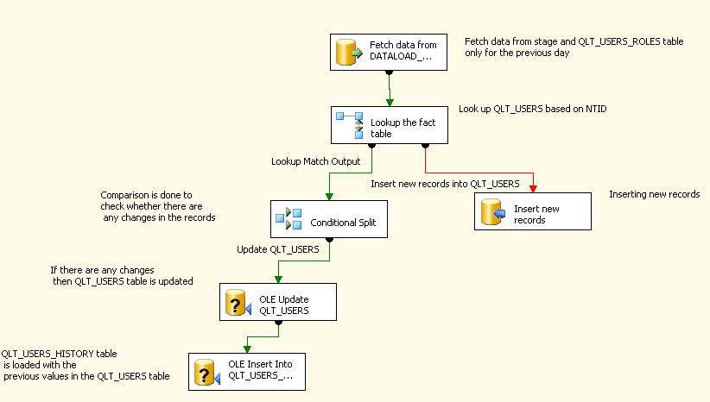

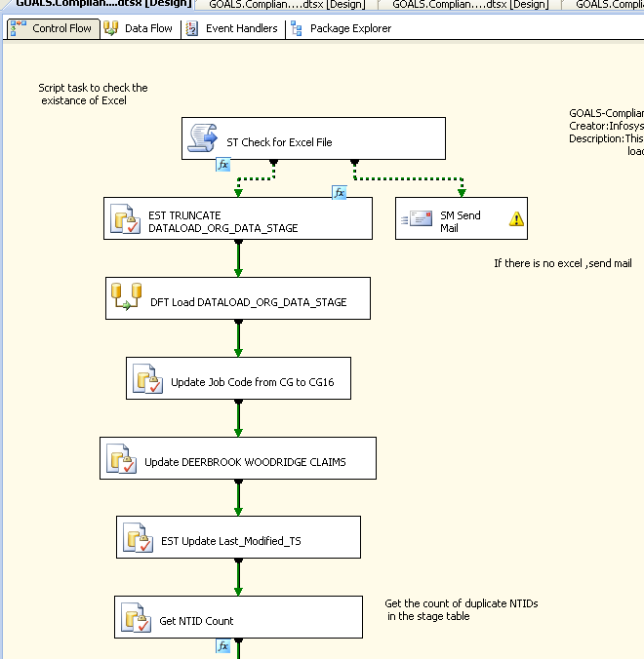

Slowly Changing Dimension

The Slowly Changing Dimension transformation coordinates the updating and inserting of records in data warehouse dimension tables. For example, you can use this transformation to configure the transformation outputs that insert and update records in the DimProduct table of the AdventureWorksDW2008R2 OLAP database with data from the Production.Products table in the AdventureWorks2008R2 OLTP database.
Important
The Slowly Changing Dimension Wizard only supports connections to SQL Server.
The Slowly Changing Dimension transformation provides the following functionality for managing slowly changing dimensions:
- Matching incoming rows with rows in the lookup table to identify new and existing rows.
- Identifying incoming rows that contain changes when changes are not permitted.
- Identifying inferred member records that require updating.
- Identifying incoming rows that contain historical changes that require insertion of new records and the updating of expired records.
- Detecting incoming rows that contain changes that require the updating of existing records, including expired ones.
The Slowly Changing Dimension transformation supports four types of changes: changing attribute, historical attribute, fixed attribute, and inferred member.
- Changing attribute changes overwrite existing records. This kind of change is equivalent to a Type 1 change. The Slowly Changing Dimension transformation directs these rows to an output named Changing Attributes Updates Output.
- Historical attribute changes create new records instead of updating existing ones. The only change that is permitted in an existing record is an update to a column that indicates whether the record is current or expired. This kind of change is equivalent to a Type 2 change. The Slowly Changing Dimension transformation directs these rows to two outputs: Historical Attribute Inserts Output and New Output.
- Fixed attribute changes indicate the column value must not change. The Slowly Changing Dimension transformation detects changes and can direct the rows with changes to an output named Fixed Attribute Output.
- Inferred member indicates that the row is an inferred member record in the dimension table. An inferred member exists when a fact table references a dimension member that is not yet loaded. A minimal inferred-member record is created in anticipation of relevant dimension data, which is provided in a subsequent loading of the dimension data. The Slowly Changing Dimension transformation directs these rows to an output named Inferred Member Updates. When data for the inferred member is loaded, you can update the existing record rather than create a new one.
Note
The Slowly Changing Dimension transformation does not support Type 3 changes, which require changes to the dimension table. By identifying columns with the fixed attribute update type, you can capture the data values that are candidates for Type 3 changes.
At run time, the Slowly Changing Dimension transformation first tries to match the incoming row to a record in the lookup table. If no match is found, the incoming row is a new record; therefore, the Slowly Changing Dimension transformation performs no additional work, and directs the row to New Output.
If a match is found, the Slowly Changing Dimension transformation detects whether the row contains changes. If the row contains changes, the Slowly Changing Dimension transformation identifies the update type for each column and directs the row to the Changing Attributes Updates Output, Fixed Attribute Output, Historical Attributes Inserts Output, or Inferred Member Updates Output. If the row is unchanged, the Slowly Changing Dimension transformation directs the row to the Unchanged Output.

